NAME:
Year 9 Term 4 – Body Systems
Revision SHEET No. 1
Learning Goal 1: Understand the role of the digestive system in the human body

- Use the following words to arrange in levels of complexity: Cell, Organism, Tissue, Body system, Organ

_________________________________________________________________

- List four nutrients used by the body AND two waste products that are removed from the body.

- What is the function of the following:
- Small intestine:
- Oesophagus:
- Stomach:
- Pancreas:
- Liver:
- Large Intestine:
- Write a definition and give an example of each of the following terms:
- Tissue:

- Organ:

- Body System (organ system):

- Organism:

- Label the organs in the following diagram:
Word List: Oesophagus, Large Intestine, Small Intestine, Pancreas, Liver, Stomach
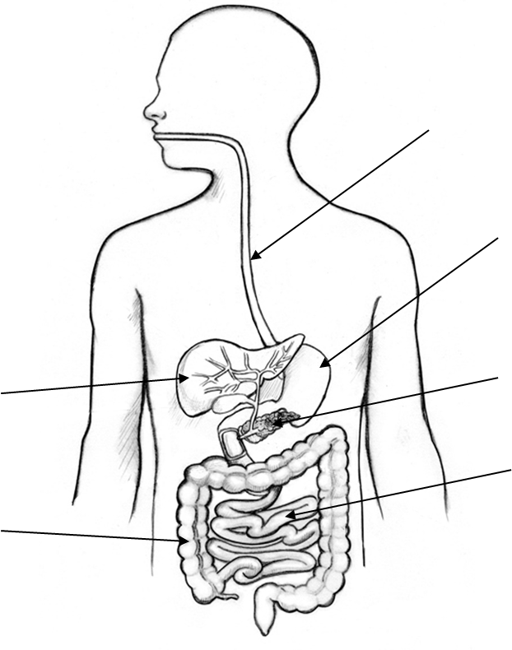
- List two body systems which work together to provide nutrients and remove wastes. Write one sentence on each system describing its role in providing the nutrients and/or removal of the waste product.

- What is the difference between mechanical digestion and chemical digestion? Give an example of each.

Learning Goal 2: Understand the role of the circulatory system in the human body
- Write a description for each of the following blood components including the component’s main function:
Plasma:

White Blood Cells:
Red Blood Cells:

- Label the parts of the heart in the following diagram:
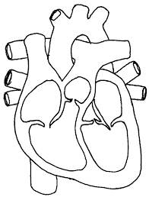
Word List: Left Atrium, Right Atrium, Left Ventricle, Right Ventricle, Aorta, Pulmonary Vein, Pulmonary Artery, Vena Cava

- Describe the function of the following three types of blood vessels:
Arteries:

Veins:

Capillaries:

- If you came across a blood vessel, how could you tell if it was:
An artery?

A vein?

A capillary?

Learning Goal 3: Understand the role of the respiratory system in the human body
- Label the parts of the respiratory system in the following diagram:
Word List: Mouth, Nose, Trachea (wind pipe), Diaphragm, Bronchi, Larynx, Rib
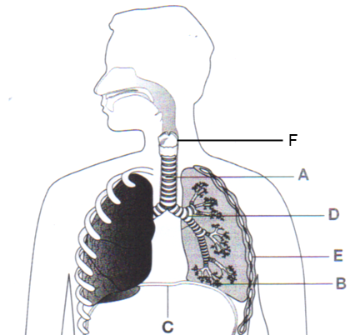
C
D=
E
F
G
H

A

B

- Why do marathon runners train in high altitude locations?

- Describe the process of gas exchange in the lungs. You should include the names of the gases and the direction they are exchanged, the parts of the lungs and circulatory system involved. (eg Alveoli).

